Trend to Ratio Study

By Lisa Ree, Ellis County, Staff Writer

- Kansas housing market grows hotter.
- Kansas home buyers will need to move fast, pay more to find a home next year.
- Will the price of houses ever come down?
- Single-family homes increase in price by $35,000 due to lumber shortage.

These are just a few of the headlines from articles I’ve collected this year. My initial intention was to use them as a tool for explaining why home values increased significantly from last year.
When we work through land and depreciation analysis, we review sales to determine if a trend is evident. We analyze paired sales, resales of properties and the ratio of sale price to appraised value. As the majority of us are experiencing this year, sale prices have increased dramatically. Whether it’s low mortgage rates, a low supply of homes for sale or a combination of both, we are seeing the effect of those headlines in our residential class sales ratios.

During the ratio study session at the KCAA conference, Pete Davis stated PVD typically will trend a county’s ratio study upon request. Their policy has been to not exceed the published market trend. Because of the aggressive market across the state, I reached out to Davis for his thoughts regarding ratio studies and applying a trend. The following is a summary of his comments.

Regarding recent ratio studies provided to counties, Davis suggests that 12 of the 21 sampling counties consider requesting a time adjustment to bring their confidence intervals into compliance. Smaller counties should review their mid-year ratio study results. If the median ratio was low, the preliminary results will most likely indicate a lower median ratio.

If a time trend is needed to pull your 2021 median ratio into compliance, the trend indicated in your 2022 market study publication will be used by PVD. The annual trend will be used to develop a monthly adjustment. Some counties publish a single market trend. Others publish multiple trends for categories like rural vs. urban, single-family, multi-family, market area, year built. PVD will apply a county’s trend to the ratio study sales accordingly. If time permits, additional groupings or an alternative trend method may be attempted if the county time trend appears to need more stratification to improve the median ratio to meet compliance requirements. A credible time trend will raise the median ratio and slightly lower the COD. A time trend will not be used if it raises the COD by more than a few tenths of a point. Trending sale prices back to January 2021 using the 2022 trend should raise the sales ratios when compared to 2021 values.

Counties have the option to use the RatioExcel program to test their ratios. The program can be downloaded from the PVD CAMA website. Instructions for using the application are included in the download. The program will calculate the median ratio and COD. It also creates a text file titled RatioReport.txt that provides the statistics calculated. Each time the RatioExcel program is used, the RatioReport.txt file is updated. This program could be a useful tool to test how a trend will affect your ratio statistics before requesting PVD apply a trend or anytime throughout the year.

Excel can be used to check how the median ratio changes after a trend is applied to sales. Starting with the file provided by PVD that includes the ratio study sales (ex. PVD2021M026) and making a few modifications, it can be used along with the RatioExcel program to calculate the ratio statistics with a trend applied.

To test what an applied trend would do to the median ratio, COD and PRD, Davis’ suggestions (almost word for word!) on modifying the PVD2021M### file are indicated below and on the following page.

The ratio worksheet can be processed by the PVD Ratio Study Excel application (RatioEx2015.exe) if the column header names are revised: change SALE column to Orig Sale$. Label the added adjusted sale price column: SaleAdjusted.

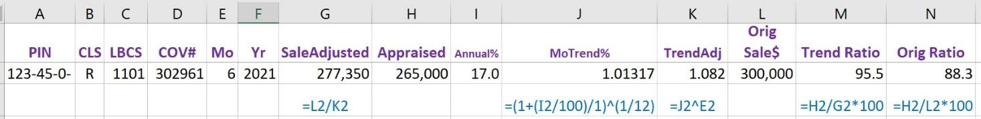

Columns added for monthly compounding increase in sale prices (cell formulas in blue):
G: SaleAdjusted: (time adjusted sale price as of January 2021 - formula =L2/K2)
I: Annual%: (developed from your trend analysis) 17.0% used for this demo example
J: MoTrend%: (monthly trend formula =(1+(I2/100)/1)^(1/12) )
K: TrendAdj: (formula for monthly compounding adjustment =J2^E2 )
M: Trend Ratio: (new column added – formula =H2/G2*100 )
N: Orig Ratio: (change name from ratio – verify or change formula =H2/L2*100 )

Notes:
These formulas (in Row 2) will need to be copied and pasted in each row with sale data.
The RatioEx2015 program will calculate and use the time trended ratio if the worksheet columns are re-labeled as shown above (from column M).
This setup assumes the sale takes place at the end of the recorded month for maximum adjustment benefit.
Appraisers can substitute a simple adjustment to replace compounding adjustment above:
Column J: MoTrend%: formula for simple monthly rate from annual trend rate =I2/12 : adjustment = .01417
Column K: TrendAdj: formula for simple monthly adjustment =1+(E2*J2) : adjustment = 1.085

Using the RatioExcel2015 program, I tested Davis’ suggestions. The first step was to run the RatioExcel2015 program using the sales provided by PVD in the ratio worksheet. This original run indicated a median ratio of 89.3 and COD of 7.5.

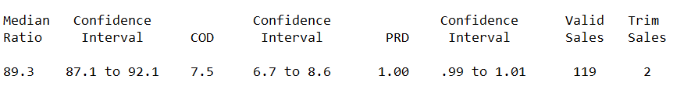
I then modified the ratio worksheet according the Davis’ directions, included an annual trend of 15% to all parcels, saved it with a different name and ran the RatioExcel2015 program. Unfortunately, I would get errors stating not able to find the column headings of Sale and APPR. I was able to work through some of the errors, but not all. Davis provided a different program, CoRatioEx2015.exe. I was able to run the stats with that program without any errors. The results were a higher median ratio and COD.

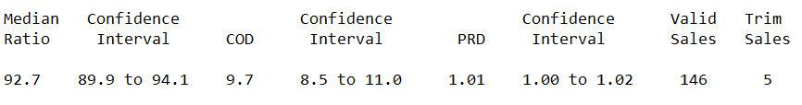
As you can see, the median ratio and COD increased when applying a time trend again. According to Davis, if the COD increases as in this instance, we may have something amiss and more stratification may be necessary. It could be that a different trend should be used for different market areas, instead of a single county-wide trend. But at least the median ratio and COD meet requirements. Davis’ opinion is that PVD is mostly concerned about the COD when it comes to the residential ratio study.

Because I procrastinated, I wasn’t able to see if other counties had issues with the RatioExcel2015 program after modifying the ratio sales file.

With the changes to the residential market we have experienced, you may benefit from trending your 2021 sales for ratio study. Using the RatioExcel2015 program and tweaking your ratio sale file slightly, you can get a snapshot of what your ratio statistics would be when applying one or more trends to those sales. Spending a little time working through the process should help you decide whether to request PVD trend your sales. For some counties it could mean moving from out of statistical compliance with a low median ratio and into compliance with an acceptable median ratio. Hope you give it a try and good luck.

